STUDENT PERFOMANCE

1. Business Understanding
The project aims to identify the key factors contributing to poor student performance in schools. The goal is to help educational institutions understand what influences academic success the most, enabling them to develop targeted interventions and policies.
Key influencing factors include:
- Parental involvement
- Learning environment
- Student motivation
- Access to resources
By understanding these factors, the project seeks to support improved teaching methods, resource allocation, and overall student outcomes.

2. Data Understanding
Dataset Source: Kaggle (Student Performance Factors dataset)
Records: 6,607
Variables: 14 (a mix of numerical and categorical data)
Key variables include:
- Demographics: Gender, parental education, parental involvement
- Behavioral factors: Attendance, hours studied, motivation levels, sleep hours,
- Environmental factors: Internet access, learning disabilities, teacher quality, peer influence, tutoring sessions
- Performance indicators: Previous scores, exam scores
Initial data exploration focused on:
- Checking data completeness and quality
- Reviewing relationships between variables
- Understanding distributions and patterns among key features

3. Data Preparation

Data cleaning and preprocessing were performed to ensure consistency and reliability.
Key steps included:
- Normalization of numeric features (e.g., attendance, hours studied, previous scores)
- Grouping and encoding categorical variables (e.g., internet access, motivation)
- Descriptive and comparative analyses to assess central tendencies and relationships
- Visualization techniques (pie charts, bar charts, line graphs, scatter plots) to detect trends and correlations

4. Modeling
Methods Used:
• Conducted descriptive and comparative analyses.
• Created visualizations to explore relationships between key factors and exam performance.

VISUALIZATIONS

Line Chart: Hours Studied vs Exam Score
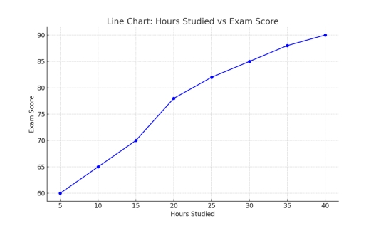

Bar Chart: Motivation Level vs Exam Score
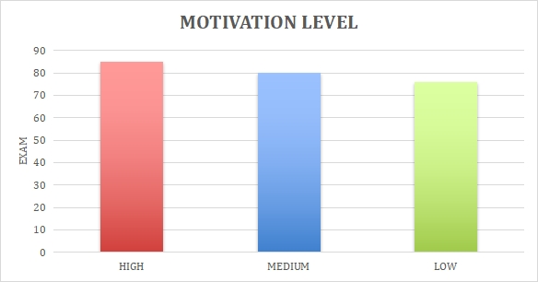

Scatter Plot: Previous Score vs Exam score
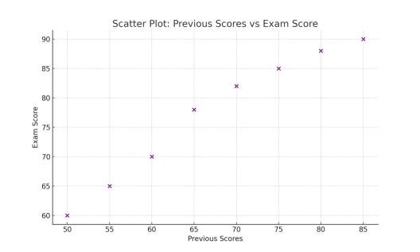
Pie Chart: Internet Access Distribution

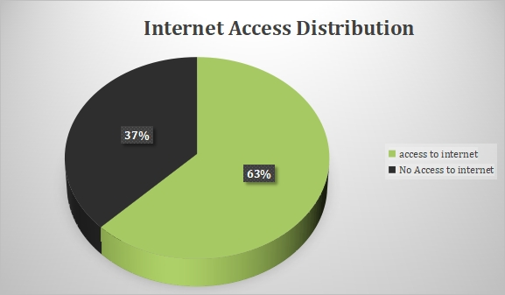

Bar Chart: Tutoring Sessions VS Exam Score

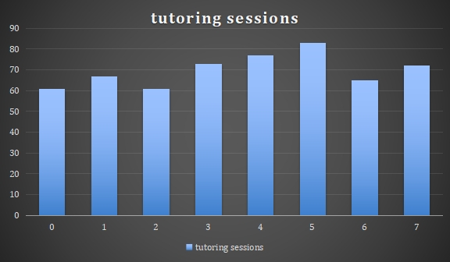

Tools Used: Python (Pandas, Matplotlib) for data analysis.

Key insights:
- More study hours generally lead to higher scores
- Motivation and internet access are strong predictors of better performance
- Previous academic performance is a reliable indicator of future results
- Over studying may lead to diminishing returns due to fatigue

5. Evaluation
The evaluation confirmed that the model supports effective educational interventions and data-d riven decision-making

Category | Insight | Interpretation
  Study Habits
  More study hours generally lead to higher scores, leveling off after about 30 hours.
  Studying improves outcomes up to a point, beyond which returns diminish.
Motivation | Highly motivated students perform noticeably better. | Motivation is a strong predictor of academic success.
Resources & Access | Students without internet access tend to perform worse. | Unequal access to digital resources contributes to performance gaps.
Historical Performance | Strong link between previous and current exam scores. | Students with consistent habits maintain steady performance.
Tutoring Support | Students who received tutoring scored higher on | Targeted tutoring effectively supports academic improvement.

6. Deployment
The final phase focuses on implementing findings and recommendations to enhance student outcomes.
Recommendation
- Dashboards and visual reports for educators and policymakers
- Suggested actions:
  - Mentoring and motivation programs
  - Improved digital access for students
  - Structured extra-class sessions
  - Early intervention for low-performing students
  - Regular performance monitoring and feedback
The deployment ensures the insights are practical and actionable for teachers, parents, and school administrators.

